THEODORE ROOSEVELT ELEMENTARY SCHOOL
BINGHAMTON - SCHOOL

School Detail :-
USD 383 has a rich history built upon the efforts of many individuals who firmly believed in the importance of public education to this community. We are proud of the tremendous breadth and depth of success attained by past and current students, and embrace expectations for continued success that are engrained in staff, parents, students, and the community-at-large.
USD 383 has a rich history built upon the efforts of many individuals who firmly believed in the importance of public education to this community. We are proud of the tremendous breadth and depth of success attained by past and current students, and embrace expectations for continued success that are engrained in staff, parents, students, and the community-at-large
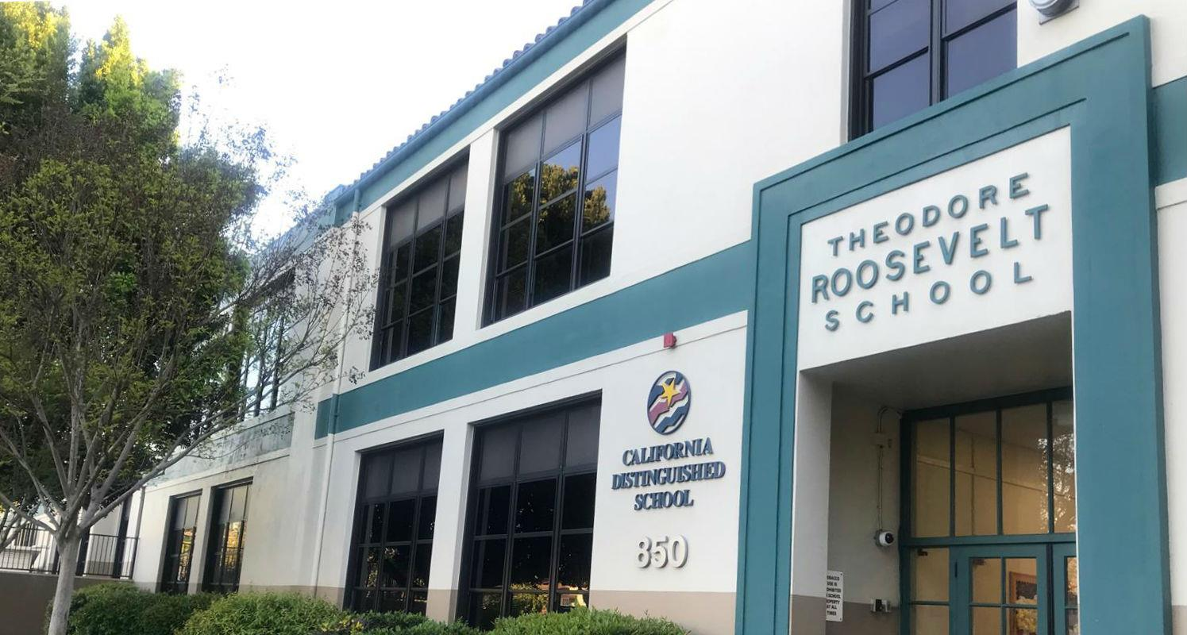

MINIMUM CAPACITY :-
The Minumum intake capacity
of students is between 1800-2000
children

LIBRARY :-
The Libarary is Available.

CANTEEN:-
The Canteen Facility is Available.

BOARDING :-
No availablility of boarding.

SPORTS :-
There are different categories
sports available.
Girls Volleyball
Boys Volleyball
Football

